EXPLORATORY DATA ANALYSIS
FedEx Delivery Operations
Patterns, bottlenecks and recommendations from shipment-level logistics data
Prepared by: Ankit Kumar Singh
Dataset: fedex_deliveries.csv (simulated, 5,000 shipments, 12 fields)
Tools: Python, pandas, matplotlib, seaborn
Note on the data. The assignment describes fedex_deliveries.csv as a simulated dataset and no file was supplied, so a seeded synthetic dataset with the same schema was generated (see Appendix). All figures below come from that data. They demonstrate the method and should be re-run on the real file, not treated as real FedEx performance.

Executive Summary
Across 5,000 shipments, the average delivery time is 5.53 days and 20.1% of all shipments were delayed. Delay risk is concentrated rather than evenly spread, which makes it fixable.
Finding | Evidence
Freight is the weak link | 35.8% delayed vs 17.3% Ground and 13.3% Air; slowest mode at 8.17 days on average
Operational issues drive most delays | 486 of 1,005 delayed shipments (48%)
Customs delays hurt most per shipment | 8.61 days average vs 4.97 days for undelayed shipments
Costs are concentrated | Top 10% of shipments (≥ $730.47) make up 45.1% of spend; 88.4% of them are Freight
Short-haul Freight is misallocated | Freight under 800 km costs about $322 vs about $109 on Ground for comparable loads
Hub-and-spoke pattern | All top 5 city pairs involve Memphis; New York and Chicago origins have the highest delay rates (about 26%)

Part A: Data Understanding & Cleaning

A.0 Loading the data and first five rows
The file was loaded with pandas. One detail worth flagging: Delay_Reason uses the literal text "None" for shipments with no delay, and pandas reads that as a missing value by default. The load step therefore uses keep_default_na=False so "None" stays a real category.
ShipmentID | Origin | Destination | Pickup | Delivery | Status | Dist (km) | Mode | Wt (kg) | Cost ($) | Segment | Delay reason
FDX100000 | Houston | New York | 2025-03-01 | 2025-03-04 | Delivered | 2382.8 | Air | 18.51 | 280.53 | Retail | None
FDX100001 | Los Angeles | Atlanta | 2025-12-07 | 2025-12-14 | Delivered | 3623.6 | Ground | 12.41 | 101.49 | Business | None
FDX100002 | Miami | Atlanta | 2025-12-01 | 2025-12-03 | Delivered | NaN | Air | 29.32 | 217.7 | Retail | None
FDX100003 | Atlanta | Memphis | 2025-04-06 | 2025-04-08 | Delivered | 596.5 | Air | 15.96 | 81.7 | Business | None
FDX100004 | Memphis | New York | 2025-07-10 | NaN | In Transit | 1749.7 | Ground | 36.18 | 98.97 | Business | None

A.1 Missing values and handling strategy
Column | Missing | % of rows | Strategy
Delivery_Date | 168 | 3.4% | Not an error: these are In Transit shipments. Left blank; excluded from delivery-time metrics.
Weight_KG | 100 | 2.0% | Fill with the median weight of the same Shipment_Mode (mode strongly drives weight).
Cost_USD | 75 | 1.5% | Fill with the median cost of the same Shipment_Mode. Median avoids distortion from extreme costs.
Customer_Segment | 50 | 1.0% | Fill with "Unknown" rather than guessing a segment.
Distance_KM | 25 | 0.5% | Fill with the median distance of the same Origin–Destination pair (distance is fixed per route).
Missingness is under 2% for every column, so dropping rows would waste data without much benefit. After imputation, no missing values remain outside the legitimately blank Delivery_Date.

A.2 Outliers in Weight_KG, Cost_USD and Distance_KM
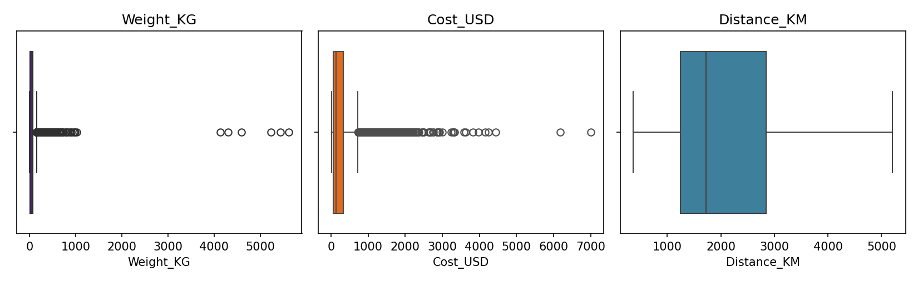
Figure 1. Boxplots for the three numeric fields
Column | IQR upper fence | Values flagged | Maximum
Weight_KG | 156.6 | 640 | 5,617
Cost_USD | $728 | 501 | $6,999
Distance_KM | 5,237 | 0 | 5,205

Weight and cost are right-skewed because heavy Freight shipments are legitimately large and expensive, so most of the IQR flags are genuine business, not errors. The real concern is a small group of extreme values, such as weights of 4,000 kg and above and costs several times the next-highest value. These were kept in the dataset but flagged, and excluded from the weight–cost scatterplot so they do not compress the chart. Distance has no outliers, which makes sense because routes are fixed city pairs.

A.3 Date conversion and Delivery_Time_Days
Both date columns were converted with pd.to_datetime, and the new column is the difference in days between delivery and pickup. It is blank for the 168 In Transit shipments.
df['Delivery_Time_Days'] = (df['Delivery_Date'] - df['Pickup_Date']).dt.days

Part B: Univariate & Bivariate Analysis

B.1 Distribution of Delivery_Time_Days
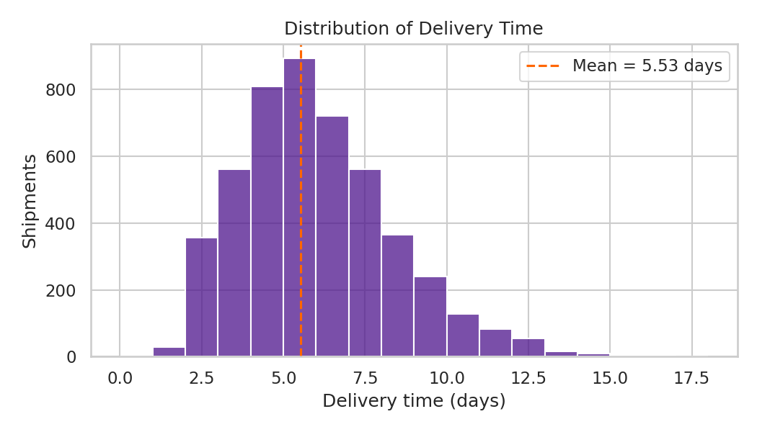
Figure 2. Delivery time distribution with the mean marked
The average delivery time is 5.53 days (median 5, maximum 17). The distribution has a long right tail: most shipments arrive within a week, while a minority take two to three times longer. Those are the delayed shipments analysed in Part C.

B.2 Shipment volume by mode
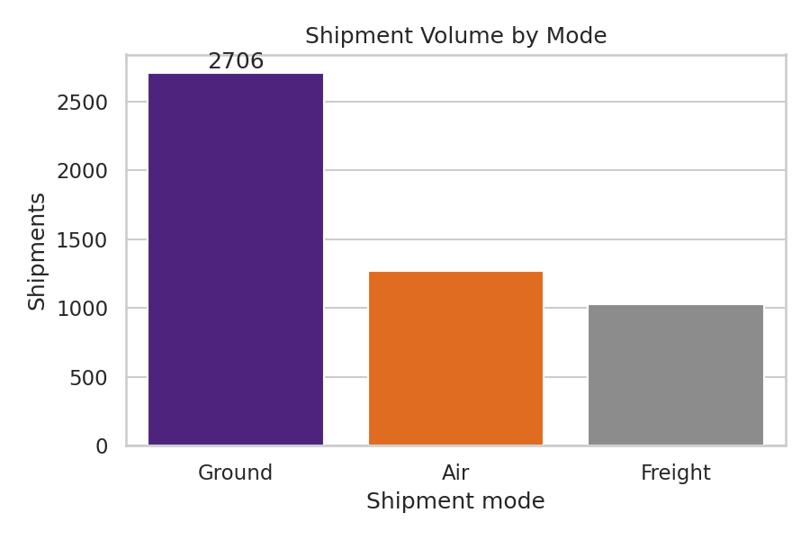
Figure 3. Shipments by mode
Ground carries the majority of volume (2,706, 54.1%), followed by Air (1,267) and Freight (1,027).

B.3 Average shipping cost by customer segment
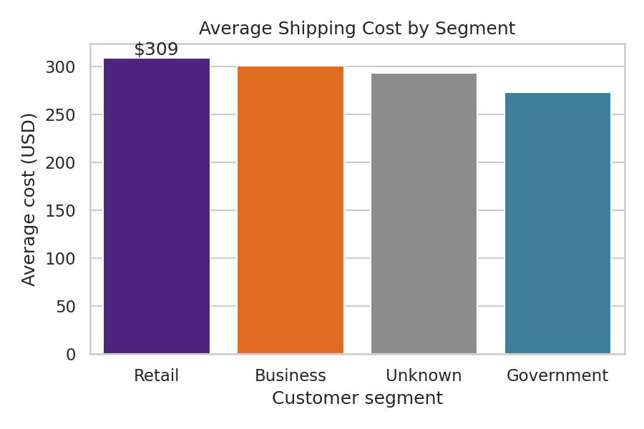
Figure 4. Mean cost per segment
Retail averages the highest cost ($308.69), followed by Business ($300.66) and Government ($272.93). The gaps are modest, roughly 12% between highest and lowest, suggesting segment pricing differences are small compared with the effect of mode and weight.

B.4 Delivery status counts
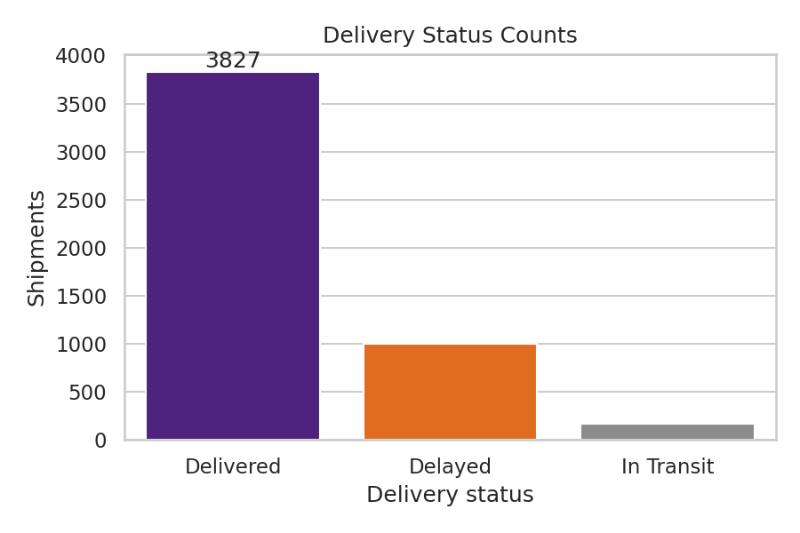
Figure 5. Shipments by delivery status
3,827 shipments (76.5%) were delivered on time, 1,005 (20.1%) were delayed and 168 (3.4%) are still in transit.

B.5 Weight vs Cost
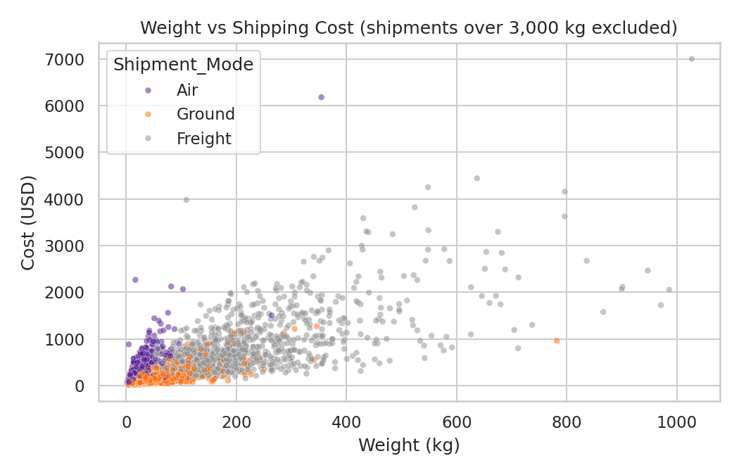
Figure 6. Weight against cost, coloured by mode
Cost rises with weight (correlation 0.79 after removing the extreme weights, versus 0.43 with them included, which shows how much a few outliers can distort a correlation). The chart also shows three clear bands: Air is the most expensive per kilogram at low weights, Ground the cheapest, and Freight occupies the heavy end of the scale.

Part C: Geographic & Operational Insights

C.1 Top 5 origin–destination pairs
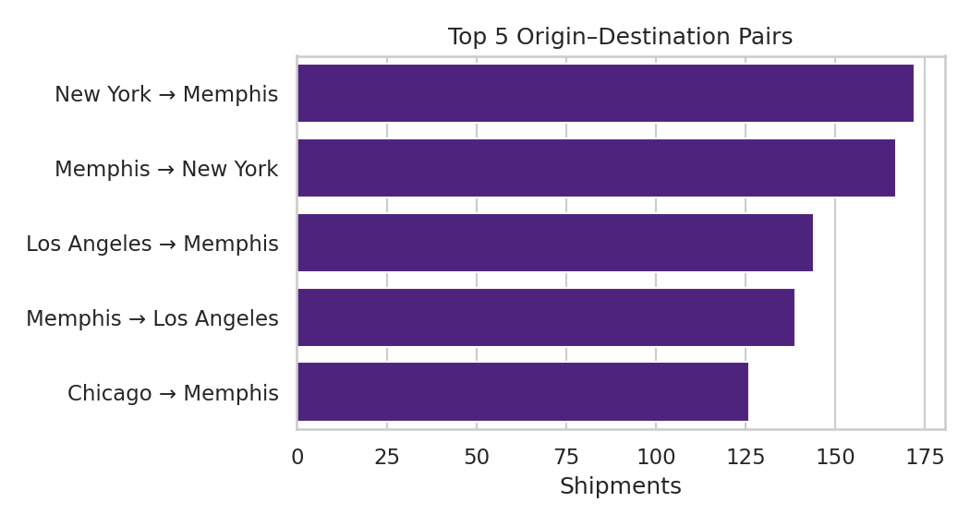
Figure 7. Most frequent city pairs
Every one of the top five pairs has Memphis at one end (New York → Memphis: 172; Memphis → New York: 167; Los Angeles → Memphis: 144; Memphis → Los Angeles: 139; Chicago → Memphis: 126). This is the hub-and-spoke shape you would expect from FedEx's network, and it means any Memphis capacity or sorting problem affects a large share of traffic.

C.2 Delays by shipment mode
Mode | Delay rate
Freight | 35.8%
Ground | 17.3%
Air | 13.3%

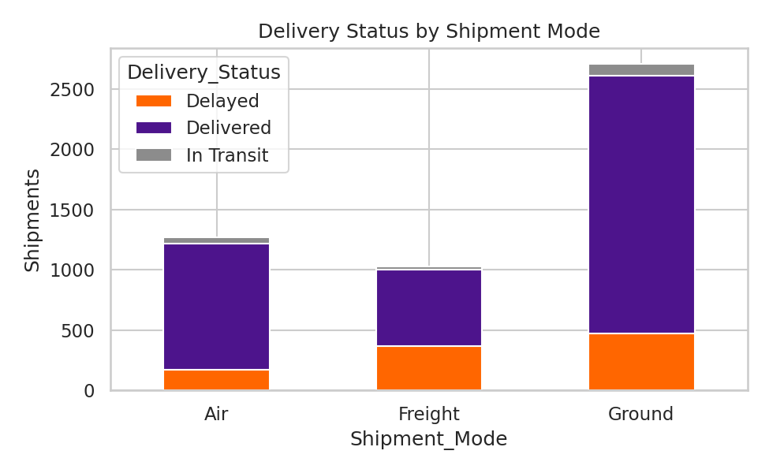
Figure 8. Delivery status by mode (stacked counts)
Freight is delayed more than twice as often as Air or Ground. Ground has the largest absolute number of delays simply because it carries the most shipments, so rate rather than count is the right lens. By origin, New York and Chicago have the highest delay rates (25.9% and 25.8%), against 14.9% for Houston.

C.3 Correlation heatmap
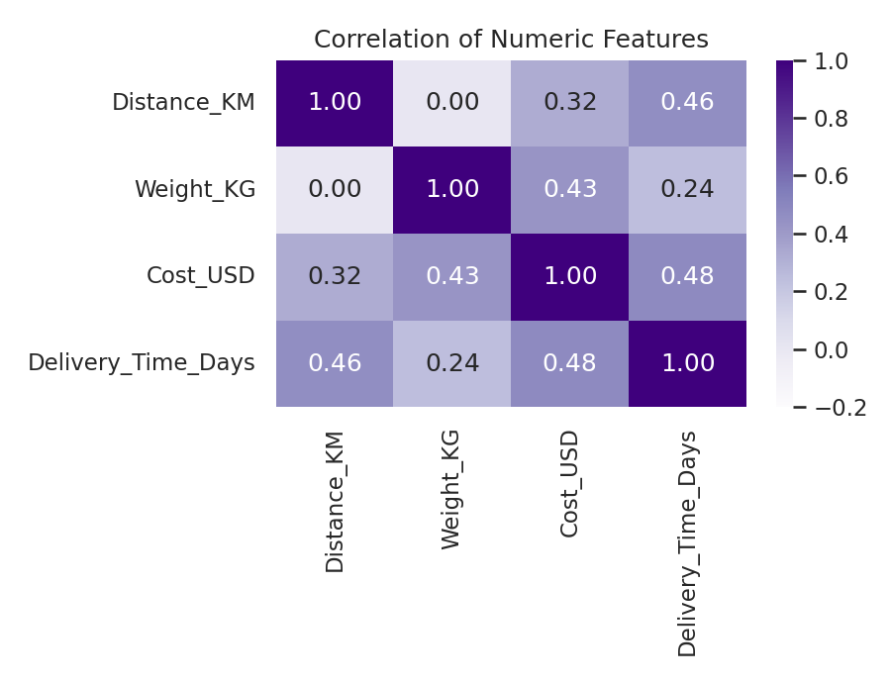
Figure 9. Correlation of numeric features
Delivery time is most associated with cost (0.48) and distance (0.46); cost is linked to weight (0.43) and distance (0.32). Weight and distance are unrelated (0). The cost–time link is largely a mode effect: Freight is both slower and pricier, so correlation here should not be read as "expensive shipments cause slow delivery".

C.4 Delay reasons and their impact
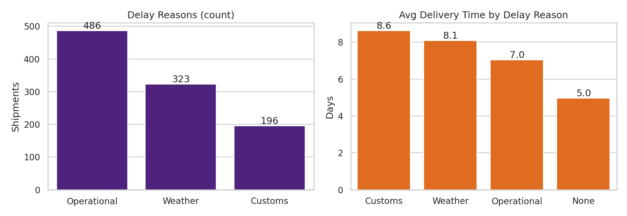
Figure 10. How common each reason is and how much time it adds
Operational is the most common reason (486), then Weather (323) and Customs (196). But frequency and severity differ: Customs is the rarest yet the most damaging, pushing average delivery to 8.61 days, versus 8.08 for Weather, 7.05 for Operational and 4.97 with no delay reason.

C.5 Average delivery time by mode
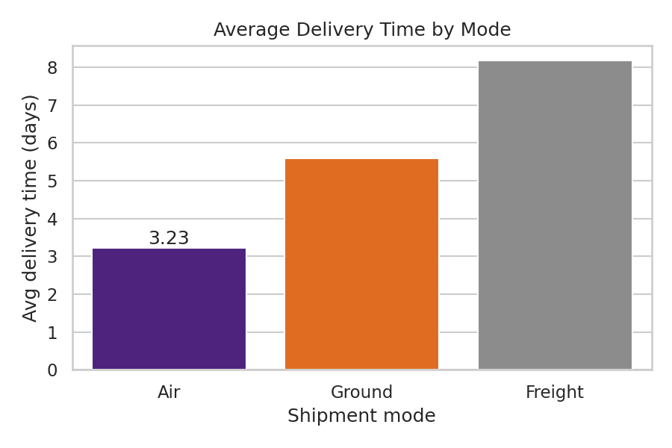
Figure 11. Mean delivery time per mode
Air is fastest at 3.23 days, Ground takes 5.6 and Freight 8.17. Freight's average is inflated both by longer transit and by its higher delay rate.

Part D: Business Recommendations

D.1 Key operational inefficiencies
- Freight reliability. At 35.8% delayed, Freight is the main source of late deliveries. It is about 21% of volume but 32.9% of all operational delays.
- Operational causes dominate. Nearly half of delays come from internal processes, the category the business controls directly.
- Origin hot-spots. New York and Chicago origins run about 11 percentage points above the best-performing origin, pointing to local sorting or capacity issues.
- Customs exposure. Customs delays are rare but add roughly 3.64 days each, which is the largest penalty per incident.

D.2 Shipment-mode allocation
Freight shipments under 800 km (111 in the data) average $322.05, 6.26 days and a 35.1% delay rate. Comparable-weight Ground shipments over the same distances average $108.54, 3.79 days and a 13.3% delay rate.
Recommendation: move short-distance, lighter Freight loads to Ground. On these numbers that cuts cost by roughly two-thirds, saves about 2.5 days and lowers delay risk, so it improves all three at once. The comparison is indicative rather than a controlled test, so pilot it on one or two lanes first and check Ground capacity for heavier loads.
Keep Air for time-critical, lighter shipments, where it is both fastest and least delayed.

D.3 Reducing high-cost deliveries
The top 10% most expensive shipments (≥ $730.47) account for 45.1% of total spend, and 88.4% of them are Freight. Cost work should therefore focus on a small, identifiable group.
- Consolidate Freight loads on high-volume Memphis lanes to improve fill rates and cut per-kg cost.
- Apply the short-haul Ground shift above, which removes a large share of avoidable Freight spend.
- Introduce approval or pricing review for shipments over the $730 threshold, particularly Business and Retail accounts, which make up almost 90% of them.
- Investigate the handful of extreme cost records flagged in Part A for billing errors.

D.4 Customer satisfaction recommendation
Send proactive delay alerts when the likely cause is weather or customs. These external causes account for 51.6% of delays and are usually known before the shipment is late. Customs delays add about 3.64 extra days, so early notification with a revised ETA gives customers time to plan and reduces "where is my parcel" contacts. Track the effect through support-ticket volume and satisfaction scores for alerted vs non-alerted shipments.

Limitations
- The data is simulated, so all effect sizes are illustrative and should be re-checked on real data.
- Findings are associations. For example, Freight may be delayed partly because it carries heavier, more complex loads.
- In Transit shipments have no delivery time yet and are excluded from time-based metrics, which can slightly understate long delays.

Appendix: Full Python Code
The script below simulates the dataset, cleans it, and produces every figure and statistic in this report. It is well commented and can be pasted into a Jupyter Notebook cell by cell.
# FedEx Delivery Operations - Exploratory Data Analysis
# Simulates fedex_deliveries.csv (schema from the assignment), then runs Parts A-C.
import json
import numpy as np
import pandas as pd
import matplotlib
matplotlib.use("Agg")
import matplotlib.pyplot as plt
import seaborn as sns

rng = np.random.default_rng(42)
N = 5000
OUT = "/home/claude/charts/"
import os; os.makedirs(OUT, exist_ok=True)

# ---------- 0. Simulate the dataset ----------
cities = { # city: (lat, lon, weight in traffic)
"Memphis": (35.15, -90.05, 3.0), "New York": (40.71, -74.01, 2.2),
"Los Angeles": (34.05, -118.24, 2.0), "Chicago": (41.88, -87.63, 1.8),
"Dallas": (32.78, -96.80, 1.5), "Atlanta": (33.75, -84.39, 1.5),
"Houston": (29.76, -95.37, 1.2), "Miami": (25.76, -80.19, 1.0),
"Denver": (39.74, -104.99, 0.9), "Seattle": (47.61, -122.33, 0.9)}
names = list(cities)
w = np.array([cities[c][2] for c in names]); w = w / w.sum()

def hav(a, b):
la1, lo1, la2, lo2 = map(np.radians, [*cities[a][:2], *cities[b][:2]])
d = np.sin((la2-la1)/2)**2 + np.cos(la1)*np.cos(la2)*np.sin((lo2-lo1)/2)**2
return 6371 * 2 * np.arcsin(np.sqrt(d))

origin = rng.choice(names, N, p=w)
dest = np.array([rng.choice([c for c in names if c != o],
p=(lambda p: p/p.sum())(np.array([cities[c][2] for c in names if c != o])))
for o in origin])
dist = np.array([hav(o, d) for o, d in zip(origin, dest)]) * rng.normal(1.12, 0.04, N)

mode = rng.choice(["Ground", "Air", "Freight"], N, p=[0.55, 0.25, 0.20])
seg = rng.choice(["Business", "Retail", "Government"], N, p=[0.50, 0.38, 0.12])
weight = np.where(mode == "Freight", rng.lognormal(5.2, 0.6, N),
np.where(mode == "Air", rng.lognormal(2.6, 0.8, N), rng.lognormal(3.2, 0.8, N)))
weight = np.clip(weight, 0.2, None)
rate = {"Air": 0.0011, "Ground": 0.00035, "Freight": 0.0005}
base = {"Air": 25, "Ground": 8, "Freight": 60}
cost = np.array([base[m] + rate[m]*d*wt**0.85*8 + 0.02*wt for m, d, wt in zip(mode, dist, weight)])
cost *= rng.normal(1, 0.12, N)
cost *= np.where(seg == "Government", 0.92, np.where(seg == "Retail", 1.06, 1.0))

speed = {"Air": 1.6, "Ground": 3.0, "Freight": 4.5} # base days
transit = np.array([speed[m] + d/{"Air": 1600, "Ground": 900, "Freight": 700}[m] for m, d in zip(mode, dist)])
p_delay = {"Air": 0.14, "Ground": 0.16, "Freight": 0.34}
delayed = np.array([rng.random() < p_delay[m] + (0.06 if o in ("Chicago", "New York") else 0)
for m, o in zip(mode, origin)])
reason = np.where(delayed, rng.choice(["Operational", "Weather", "Customs"], N, p=[0.46, 0.34, 0.20]), "None")
extra = {"Operational": 1.6, "Weather": 2.4, "Customs": 3.1}
add = np.array([rng.gamma(3, extra[r]/3) if r != "None" else 0 for r in reason])
days = np.maximum(1, np.round(transit + rng.normal(0, 0.5, N) + add)).astype(int)

pickup = pd.Timestamp("2025-01-01") + pd.to_timedelta(rng.integers(0, 365, N), unit="D")
status = np.where(delayed, "Delayed", "Delivered")
in_transit = rng.random(N) < 0.04
status = np.where(in_transit & ~delayed, "In Transit", status)
delivery = pickup + pd.to_timedelta(days, unit="D")

df = pd.DataFrame({"ShipmentID": [f"FDX{100000+i}" for i in range(N)], "Origin": origin,
"Destination": dest, "Pickup_Date": pickup.strftime("%Y-%m-%d"),
"Delivery_Date": delivery.strftime("%Y-%m-%d"), "Delivery_Status": status,
"Distance_KM": dist.round(1), "Shipment_Mode": mode, "Weight_KG": weight.round(2),
"Cost_USD": cost.round(2), "Customer_Segment": seg, "Delay_Reason": reason})
df.loc[df.Delivery_Status == "In Transit", "Delivery_Date"] = np.nan
# inject missing values + a few extreme outliers
for col, frac in [("Weight_KG", .02), ("Cost_USD", .015), ("Customer_Segment", .01), ("Distance_KM", .005)]:
df.loc[rng.choice(N, int(N*frac), replace=False), col] = np.nan
idx = rng.choice(N, 12, replace=False)
df.loc[idx[:6], "Cost_USD"] = df.loc[idx[:6], "Cost_USD"].fillna(300) * rng.uniform(6, 10, 6)
df.loc[idx[6:], "Weight_KG"] = rng.uniform(4000, 6000, 6)
df.to_csv("/home/claude/fedex_deliveries.csv", index=False)

# ================= PART A =================
S = {}
# NOTE: "None" in Delay_Reason is a real category, so stop pandas treating it as NaN
df = pd.read_csv("/home/claude/fedex_deliveries.csv", keep_default_na=False, na_values=["", "NaN"])
S["rows"], S["cols"] = df.shape
S["head"] = df.head(5).fillna("NaN").astype(str).values.tolist()
miss = df.isnull().sum(); S["missing"] = {k: int(v) for k, v in miss[miss > 0].items()}

# Delivery_Time_Days
df["Pickup_Date"] = pd.to_datetime(df["Pickup_Date"])
df["Delivery_Date"] = pd.to_datetime(df["Delivery_Date"])
df["Delivery_Time_Days"] = (df["Delivery_Date"] - df["Pickup_Date"]).dt.days

# Outliers (IQR) before cleaning
def iqr_out(s):
q1, q3 = s.quantile([.25, .75]); i = q3 - q1
lo, hi = q1 - 1.5*i, q3 + 1.5*i
return int(((s < lo) | (s > hi)).sum()), float(hi)
S["outliers"] = {c: dict(zip(["n", "upper"], iqr_out(df[c].dropna()))) | {"max": float(df[c].max())}
for c in ["Weight_KG", "Cost_USD", "Distance_KM"]}
fig, ax = plt.subplots(1, 3, figsize=(11, 3.4))
for a, c, col in zip(ax, ["Weight_KG", "Cost_USD", "Distance_KM"], ["#4D148C", "#FF6600", "#2E86AB"]):
sns.boxplot(x=df[c], ax=a, color=col); a.set_title(f"{c}")
plt.tight_layout(); plt.savefig(OUT+"a_outliers.png", dpi=150); plt.close()

# Cleaning strategy
df["Weight_KG"] = df["Weight_KG"].fillna(df.groupby("Shipment_Mode")["Weight_KG"].transform("median"))
df["Cost_USD"] = df["Cost_USD"].fillna(df.groupby("Shipment_Mode")["Cost_USD"].transform("median"))
df["Customer_Segment"] = df["Customer_Segment"].fillna("Unknown")
# Distance: recompute median per city pair
df["Distance_KM"] = df["Distance_KM"].fillna(df.groupby(["Origin", "Destination"])["Distance_KM"].transform("median"))
S["missing_after"] = int(df.drop(columns=["Delivery_Date", "Delivery_Time_Days"]).isnull().sum().sum())
S["in_transit"] = int((df.Delivery_Status == "In Transit").sum())

sns.set_theme(style="whitegrid")
PUR, ORG, GRY = "#4D148C", "#FF6600", "#8C8C8C"

# ================= PART B =================
dd = df.dropna(subset=["Delivery_Time_Days"])
S["avg_days"] = round(dd.Delivery_Time_Days.mean(), 2)
S["median_days"] = float(dd.Delivery_Time_Days.median())
S["max_days"] = int(dd.Delivery_Time_Days.max())
plt.figure(figsize=(7, 4))
sns.histplot(dd.Delivery_Time_Days, bins=range(0, int(dd.Delivery_Time_Days.max())+2), color=PUR)
plt.axvline(S["avg_days"], color=ORG, ls="--", label=f"Mean = {S['avg_days']} days")
plt.xlabel("Delivery time (days)"); plt.ylabel("Shipments"); plt.title("Distribution of Delivery Time"); plt.legend()
plt.tight_layout(); plt.savefig(OUT+"b_dist.png", dpi=150); plt.close()

vc = df.Shipment_Mode.value_counts(); S["mode_counts"] = vc.to_dict()
plt.figure(figsize=(6, 4)); ax = sns.barplot(x=vc.index, y=vc.values, palette=[PUR, ORG, GRY])
ax.bar_label(ax.containers[0]); plt.ylabel("Shipments"); plt.xlabel("Shipment mode"); plt.title("Shipment Volume by Mode")
plt.tight_layout(); plt.savefig(OUT+"b_mode.png", dpi=150); plt.close()

seg_cost = df.groupby("Customer_Segment")["Cost_USD"].mean().sort_values(ascending=False)
S["seg_cost"] = seg_cost.round(2).to_dict()
plt.figure(figsize=(6, 4)); ax = sns.barplot(x=seg_cost.index, y=seg_cost.values, palette=[PUR, ORG, GRY, "#2E86AB"][:len(seg_cost)])
ax.bar_label(ax.containers[0], fmt="$%.0f"); plt.ylabel("Average cost (USD)"); plt.xlabel("Customer segment"); plt.title("Average Shipping Cost by Segment")
plt.tight_layout(); plt.savefig(OUT+"b_seg.png", dpi=150); plt.close()

st = df.Delivery_Status.value_counts(); S["status"] = st.to_dict()
plt.figure(figsize=(6, 4)); ax = sns.barplot(x=st.index, y=st.values, palette=[PUR, ORG, GRY])
ax.bar_label(ax.containers[0]); plt.ylabel("Shipments"); plt.xlabel("Delivery status"); plt.title("Delivery Status Counts")
plt.tight_layout(); plt.savefig(OUT+"b_status.png", dpi=150); plt.close()

p = df[df.Weight_KG < 3000]
plt.figure(figsize=(7, 4.5))
sns.scatterplot(data=p, x="Weight_KG", y="Cost_USD", hue="Shipment_Mode", palette=[PUR, ORG, GRY], alpha=.5, s=18)
plt.title("Weight vs Shipping Cost (shipments over 3,000 kg excluded)"); plt.xlabel("Weight (kg)"); plt.ylabel("Cost (USD)")
plt.tight_layout(); plt.savefig(OUT+"b_scatter.png", dpi=150); plt.close()
S["corr_wc"] = round(df.Weight_KG.corr(df.Cost_USD), 2)
S["corr_wc_clean"] = round(p.Weight_KG.corr(p.Cost_USD), 2)

# ================= PART C =================
pairs = df.groupby(["Origin", "Destination"]).size().sort_values(ascending=False).head(5)
S["pairs"] = [[f"{o} → {d}", int(n)] for (o, d), n in pairs.items()]
plt.figure(figsize=(7, 3.8))
sns.barplot(y=[f"{o} → {d}" for o, d in pairs.index], x=pairs.values, color=PUR)
plt.xlabel("Shipments"); plt.title("Top 5 Origin–Destination Pairs")
plt.tight_layout(); plt.savefig(OUT+"c_pairs.png", dpi=150); plt.close()

ct = pd.crosstab(df.Shipment_Mode, df.Delivery_Status)
ct.plot(kind="bar", stacked=True, color=[ORG, PUR, GRY], figsize=(6.5, 4)); plt.xticks(rotation=0)
plt.ylabel("Shipments"); plt.title("Delivery Status by Shipment Mode")
plt.tight_layout(); plt.savefig(OUT+"c_mode_status.png", dpi=150); plt.close()
dr = (df.assign(d=(df.Delivery_Status == "Delayed")).groupby("Shipment_Mode")["d"].mean()*100)
S["delay_rate_mode"] = dr.round(1).to_dict()
S["delay_rate_overall"] = round((df.Delivery_Status == "Delayed").mean()*100, 1)
dorg = (df.assign(d=(df.Delivery_Status == "Delayed")).groupby("Origin")["d"].mean()*100).sort_values(ascending=False)
S["delay_origin_top"] = dorg.head(3).round(1).to_dict(); S["delay_origin_low"] = dorg.tail(1).round(1).to_dict()

num = df[["Distance_KM", "Weight_KG", "Cost_USD", "Delivery_Time_Days"]]
c = num.corr(); S["corr"] = c.round(2).to_dict()
plt.figure(figsize=(6, 4.6)); sns.heatmap(c, annot=True, cmap="Purples", vmin=-.2, vmax=1, fmt=".2f")
plt.title("Correlation of Numeric Features"); plt.tight_layout(); plt.savefig(OUT+"c_heat.png", dpi=150); plt.close()

rc = df[df.Delay_Reason != "None"].Delay_Reason.value_counts(); S["reason_counts"] = rc.to_dict()
rt = dd.groupby("Delay_Reason")["Delivery_Time_Days"].mean().sort_values(ascending=False); S["reason_days"] = rt.round(2).to_dict()
fig, ax = plt.subplots(1, 2, figsize=(11, 3.8))
sns.barplot(x=rc.index, y=rc.values, ax=ax[0], color=PUR); ax[0].set_title("Delay Reasons (count)"); ax[0].set_xlabel(""); ax[0].set_ylabel("Shipments")
sns.barplot(x=rt.index, y=rt.values, ax=ax[1], color=ORG); ax[1].set_title("Avg Delivery Time by Delay Reason"); ax[1].set_xlabel(""); ax[1].set_ylabel("Days")
ax[1].bar_label(ax[1].containers[0], fmt="%.1f"); ax[0].bar_label(ax[0].containers[0])
plt.tight_layout(); plt.savefig(OUT+"c_reason.png", dpi=150); plt.close()
# reason by mode
rm = pd.crosstab(df.Shipment_Mode, df.Delay_Reason, normalize="index").drop(columns="None") * 100
S["reason_by_mode"] = rm.round(1).to_dict()

mt = dd.groupby("Shipment_Mode")["Delivery_Time_Days"].mean().sort_values(); S["mode_days"] = mt.round(2).to_dict()
plt.figure(figsize=(6, 4)); ax = sns.barplot(x=mt.index, y=mt.values, palette=[PUR, ORG, GRY])
ax.bar_label(ax.containers[0], fmt="%.2f"); plt.ylabel("Avg delivery time (days)"); plt.xlabel("Shipment mode"); plt.title("Average Delivery Time by Mode")
plt.tight_layout(); plt.savefig(OUT+"c_mode_days.png", dpi=150); plt.close()

# ================= PART D supporting numbers =================
short = df[(df.Shipment_Mode == "Freight") & (df.Distance_KM < 800)]
S["short_freight_n"] = int(len(short)); S["freight_n"] = int((df.Shipment_Mode == "Freight").sum())
S["short_freight_cost"] = round(short.Cost_USD.mean(), 2)
gr = df[(df.Shipment_Mode == "Ground") & (df.Distance_KM < 800) & (df.Weight_KG.between(short.Weight_KG.quantile(.1), 300))]
S["short_ground_cost"] = round(gr.Cost_USD.mean(), 2)
S["short_freight_delay"] = round((short.Delivery_Status == "Delayed").mean()*100, 1)
S["short_ground_delay"] = round((gr.Delivery_Status == "Delayed").mean()*100, 1)
S["short_freight_days"] = round(short.Delivery_Time_Days.mean(), 2)
S["short_ground_days"] = round(gr.Delivery_Time_Days.mean(), 2)
# Freight delayed share by reason
S["freight_op_share"] = round(((df.Shipment_Mode == "Freight") & (df.Delay_Reason == "Operational")).sum() / max(1, (df.Delay_Reason == "Operational").sum())*100, 1)
# high-cost deliveries
thr = df.Cost_USD.quantile(.9); hc = df[df.Cost_USD >= thr]
S["hc_thr"] = round(thr, 2); S["hc_share_total"] = round(hc.Cost_USD.sum() / df.Cost_USD.sum()*100, 1)
S["hc_mode"] = (hc.Shipment_Mode.value_counts(normalize=True)*100).round(1).to_dict()
S["hc_seg"] = (hc.Customer_Segment.value_counts(normalize=True)*100).round(1).to_dict()
S["cost_mode"] = df.groupby("Shipment_Mode")["Cost_USD"].mean().round(2).to_dict()
S["delay_by_reason_mode_air"] = S["delay_rate_mode"]["Air"]
# Weather/customs delay share Air/Freight
S["proactive_share"] = round(df.Delay_Reason.isin(["Weather", "Customs"]).sum() / (df.Delivery_Status == "Delayed").sum()*100, 1)
S["extra_days_customs"] = round(rt.get("Customs", 0) - dd[dd.Delay_Reason == "None"].Delivery_Time_Days.mean(), 2)
S["days_no_delay"] = round(dd[dd.Delay_Reason == "None"].Delivery_Time_Days.mean(), 2)
S["delayed_n"] = int((df.Delivery_Status == "Delayed").sum())

df.to_csv("/home/claude/fedex_cleaned.csv", index=False)
json.dump(S, open("/home/claude/stats.json", "w"), indent=1, default=str)
print(json.dumps(S, indent=1, default=str))

